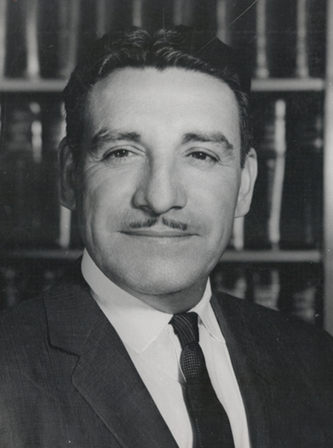
Life and Legacy of Raul H. Castro High School Lesson Series
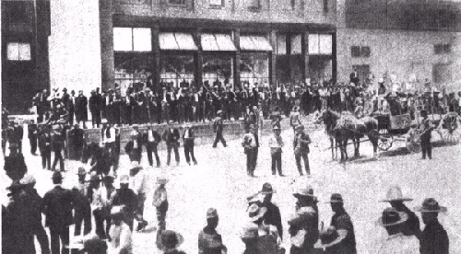
History Lesson: The Cananea Massacre in Pre-Revolutionary Mexico

Cananea Massacre Teacher Guide
The Cananea Massacre took place in 1906, ten years before the future governor of Arizona Raul H. Castro would be born there. Castro’s father would also be a labor leader and get arrested for protesting terrible mining conditions. This lesson both highlights the experience of Castro’s family and gives students information about the labor unrest in pre-revolutionary Mexico. This is a primary source focused lesson; students will analyze different primary sources and use the sources to help tell the story of the Canenea Massacre. As part of this lesson students will analyze...
- Photos
- Newspaper articles
- Cultural artifacts
The recommended length for this lesson is three days, but that may be adjusted, and the resources may be used according to the needs of the class.
Resources and Background Information
The following resources can be used to learn more about Governor Raul Castro to teach the class more about Arizona’s first and only Mexican governor. There are also a few sources to give more context to the Cananea Massacre for the teacher.
- http://digitalcommons.library.arizona.edu/x/exhibits/rhcastro/lifestory UA Special Collections
- The autobiography Adversity Is My Angel: The Life and Career of Raul H. Castro, check local library for availability
- https://www.archivetucson.com/people/2019/6/7/castro-beth Oral interview with daughter Beth Castro
- https://archive.org/details/mexicanrevolutio0000knig/page/146/mode/2up The Mexican Revolution by Alan Knight
- https://tucson.com/news/local/strike-signaled-change-at-the-cananea-mines-operated-by-col/article_1aaa84f9-43e7-5ca9-86a1-755b79cd4d87.html Article about Col Greene, the mine operator
Arizona History and Social Science Standards:
Disciplinary Skills and Processes
- HS.SP1.1 Evaluate how events and developments were shaped by unique circumstances of time and place as well as broader contexts.
- HS.SP1.3 Evaluate the significance of past events as they relate to their own lives and the world.
- HS.SP1.4 Use compelling questions generated about individuals and groups to assess how the significance of their actions changes over time and is shaped by the historical context.
- HS.SP3.2 Gather relevant information from multiple sources representing a wide range of views while using origin, authority, structure, context, and corroborative value of the source to guide the selection.
- HS.SP3.1 Develop and frame questions about issues and events in the discipline and determine the types of sources that will be helpful in answering these questions.
- HS.SP3.3 Analyze the relationship between primary sources and the secondary interpretations made from them including possible limitations in various kinds of evidence and differing secondary interpretations.
- HS.SP3.4 Evaluate the credibility of a source by examining how experts value the source.
History
Cycles of conflict and cooperation have shaped relations among people, places, and environments.
• HS.H2.1 Explain multiple causes of conflict.
• HS.H2.2 Analyze approaches to conflict management and resolution.
• HS.H2.3 Evaluate the short- and long- term impacts of conflicts and their resolutions.
• HS.H4.1 Examine how historically marginalized groups have affected change on political and social institutions

Lesson Overview

Day 1- The lesson can start with a general discussion on labor unions and their goals and motivations throughout the ages. A discussion on the difference between secondary and primary sources may also be useful. Students and teachers will work through together the Raul Castro worksheet as an example of conditions that cause labor unrest.

Day 2- Students may be divided into groups or work individually as they are assigned one of the primary source sheets. Students will analyze the sources and answer the accompanying questions. Students are also encouraged to do their own research and search secondary sources about the Cananea Massacre for additional context.

Day 3- Students will share either individually or as a group what they have learned about the massacre through their primary sources. The lesson may end with a discussion about current examples of labor unrest and how this history relates to it. There is also ample opportunity to discuss bias in media and sources that we analyze.

Raul Castro Activity Sheet

Read the following excerpt from the biography of Gov. Raul Castro. As you read, think about what sort of conditions precipitated labor unrest in Mexico. What were some of the consequences?

“Soon my father and mother heard that new jobs were available to the north in the smelter and mines of an emerging mining empire in Cananea, Sonora. Colonel William Cornell Greene— a powerful and colorful cattle baron, copper mine owner, and self-promoter in Cochise County on the Arizona side of the border— owned the Cananea Consolidated Copper Company, or the ‘Four Cs.’ Cananea lies thirty miles south of the Arizona border, about halfway between Nogales, Arizona, and Douglas, Arizona. Not surprisingly, Greene exploited the Mexican workforce. Conditions and wages were terrible, but fortunately my father, who now had eight children to feed, found jobs in both the smelter and in the American owned mines in 1914. Due to the exploitation and dreadful employment practices, my father became involved in the miners’ union, called Sindicato Sesenta y Cinco (Union Sixty-Five).
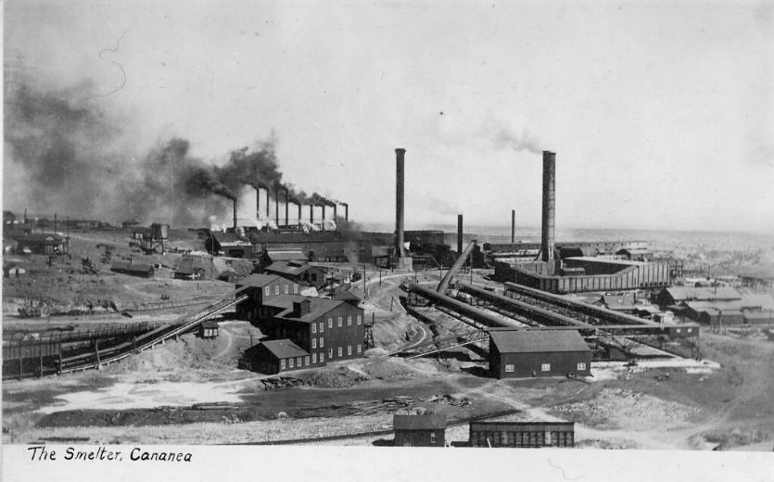
My father became a union leader and took part in setting up an unsuccessful strike. Greene responded by labeling my father a ‘rabble-rouser,’ and he convinced the Mexican authorities to arrest and jail him at the capital in Hermosillo. My father spent six months in prison, and after several efforts to free him my sister, Enriqueta, smuggled crucial information to him. As an upshot of this and other entreaties, the Mexican government agreed to an amnesty and political asylum. Ironically, they released my father from prison on the condition that he left Mexico. The entire family immigrated to the United States, to the little town of Pirtleville, Arizona, about four miles northwest of Douglas.” -Raul Castro, Adversity Is My Angel: The Life and Career of Raul H. Castro

Watch the following brief video together as a class and discuss how Castro viewed his own hardships from his early life.

https://www.youtube.com/watch?v=dr1CuhWtED0&t=10s

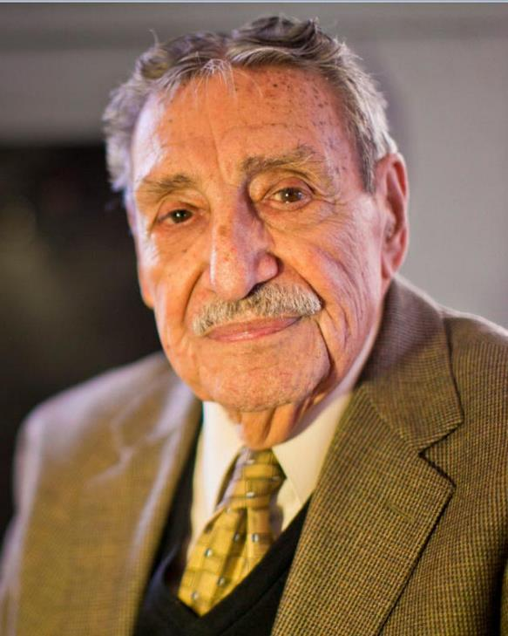

Labor conflicts are often messy affairs. Governor Castro’s family survived their dispute with bosses, but many others did not. What do you think the voices of those who did not make it would say about labor conflict if they were here today?

What are some of the differences between labor disputes in the days of Raul Castro’s childhood and modern protests against unfair conditions? How much has changed?

How do you think Gov. Castro would respond to current movements for racial and labor equality if he were alive today?
Primary Source Sheet #1- Photos
Now it is your turn to do some work as a historian and analyze some primary sources. The following photos were taken during the unrest in Cananea. Pay close attention to the images. What conclusions can you draw from them?
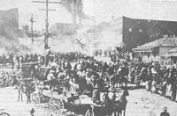
What do you notice about the buildings in the background in this picture?

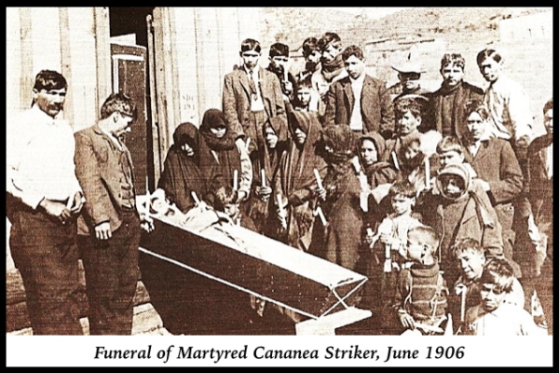
How were those killed treated by their loved ones? How do you think they were treated by the government?
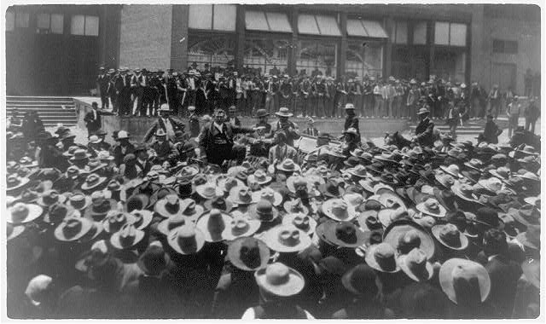
What can you infer about the miners and the labor organizers from this picture?

Now that you have analyzed some primary sources yourself, conduct your own research to find secondary sources that give more context to the pictures. Prepare to share briefly with the class what you have learned about the Cananea Massacre of 1906 through these primary sources and your own research.
Primary Source Sheet #2- Newspaper articles
Now it is your turn to do some work as a historian and analyze some primary sources. The following newspaper articles and headlines are fromd the unrest in Cananea. Pay close attention to the wording and framing. What conclusions can you draw from them? What possible biases could exist?

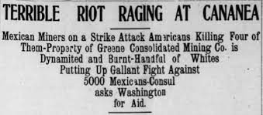
What is the difference between the word riot and the word massacre? Why do you think this headline omits the deaths of any Mexican miners?

Read the following modern article about the Cananea Massacre. How has the media’s perception of the event changed over time? Why do you think that change occurs?
https://tucson.com/news/local/strike-signaled-change-at-the-cananea-mines-operated-by-col/article_1aaa84f9-43e7-5ca9-86a1-755b79cd4d87.html

Compare the modern article with the account published on the following page. Think about the presence of bias in news.
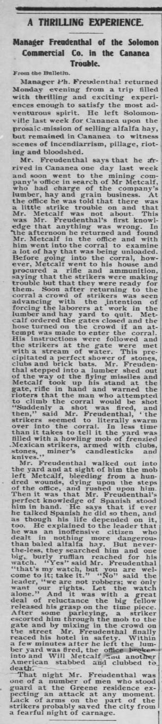

After reading the following article, conduct your own secondary research to learn more about what happened in 1906 in Cananea. How does what you found compare to the accounts you read about in newspapers? Prepare to share what you have learned about newspapers as primary sources to the rest of the class.

Primary Source Sheet #3- Cultural Artifacts
Now it is your turn to do some work as a historian and analyze some primary sources. The following corrido or song was written about the events in Cananea in 1906. Pay close attention to the wording and perspective. What conclusions can you draw from them? What possible biases could exist?

English translation:
I am going to recount to you all what happened to me, (2x)
They've taken me prisoner for being an oft-played fighting rooster. (2x)

I went to Agua Prieta to see who would recognize me, (2x)
And at eleven o'clock that night, the police apprehended me. (2x)

The officers* grabbed me in the gringo style, (2x)
Like a wanted fugitive, all of them with pistols in their hands. (2x)

The jail of Cananea is situated up on a mesa, (2x)
Where I was "processed" because of my careless blunder. (2x)

A farewell I do not give because I do not carry it here. (2x)
I leave it to the Holy Child and the Lord of Mapimí. (2x)

Look up unfamiliar terms in the song to understand better what the miners are referring to. Conduct your own research using secondary sources to learn more about what happened in Cananea in 1906. Based on the song, how do you think the memory of the massacre lives on in the memories of the miners?

Listen to a recording of the song here: https://www.youtube.com/watch?v=MLt4TvNBAxM
What is the tone of the song? Conduct more research about the history of corridos and their importance to Mexican culture and History.

Now that you have learned more about the cultural legacy of the Cananea Massacre of 1906, prepare to share what you have learned with the rest of the class.

