Amazing Amazon Life
Take a trek through Brazil's mighty Amazon River and its basin. Which unusual creatures will you encounter in this spectacular rainforest?
Grades: 4-6th
Time: 60 to 90 Minutes

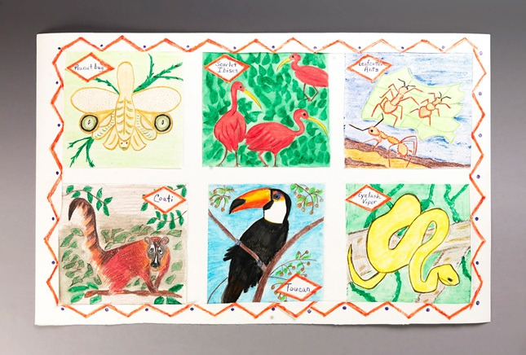

Directions
  - Have students’ research information about Brazil, the Amazon River and its basin, which contains the largest rainforest in the world. Find descriptions and pictures of animals, birds, and insects who live only in this part of the world. Here's one way to display six of these creatures on a poster.
  - Students draw a square on white paper with Crayola® Colored Pencils or Color Sticks. Trace and draw five more squares. Use Crayola Scissors to cut them out.
  - On each square, draw, color, and label a unique creature found only in the Amazon basin or rainforest. Show lots of details, so others can see how different these creatures are from those that are familiar.
  - Arrange the six pictures in an artistic way on poster board. Attach them with Crayola Glue Sticks. Design the outer edge of the poster to unify the display.
Standards
LA: Gather relevant information from multiple print and digital sources, assess the credibility and accuracy of each source, and integrate the information while avoiding plagiarism.
LA: Draw evidence from literary or informational texts to support analysis, reflection, and research.
LA: Prepare for and participate effectively in a range of conversations and collaborations with diverse partners, building on others' ideas and expressing their own clearly and persuasively.
MATH: Summarize numerical data sets in relation to their context.
SCI: Construct drawings or diagrams as representations of events or systems.
SCI: Construct explanations of phenomena using knowledge of accepted scientific theory and linking it to models and evidence.
SCI: Use words, tables, diagrams, and graphs to communicate understanding or to ask questions.
SS: Examine the interaction of human beings and their physical environment, the use of land, building of cities, and ecosystem changes in selected locales and regions.
SS: Identify examples of laws and policies that govern scientific and technological applications, such as the Endangered Species Act and environmental protection policies.
VA: Use visual structures of art to communicate ideas.
VA: Select and use subject matter, symbols, and ideas to communicate meaning.
VA: Know that the visual arts have both a history and specific relationships to various cultures.
Adaptations
Students can create a topographical map of Brazil showing the five main regions of this country, the Amazon River and its basin, and the largest cities.
Students can research Tirandentes to find out why he is significance in Brazilian history. This research should be summarized in essay format and able to be displayed in the classroom, either in paper format or electronically.
Research of well-known Brazilian artists, such as Candido Portinari, can be conducted either individually or in small groups. Students should include an investigation into the artist's style. Students can present their researched information in the form of a PowerPoint presentation and include actual works of art in the slides. This can be posted electronically on a classroom computer for viewing.
Global warming is affecting the rainforests of the world. Students can research how global warming is changing the rainforests of Brazil. Students can create a newscast of their findings and "report" these findings in the form of a video for class viewing. Class members can view and discuss how they can, individually or as a group, work towards lessening these effects on the rainforests.

