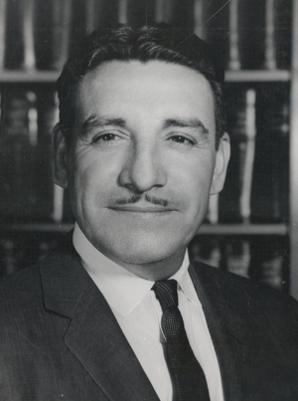
Life and Legacy of Raul H. Castro High School Lesson Series
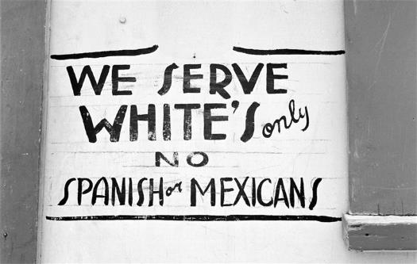

History Lesson: Latinx Segregation in the Southwest

Latinx Segregation Teacher Guide

Raul Castro eventually became Arizona’s 14th governor, but while he was growing up in Arizona, he faced discrimination through segregation like many other Mexican immigrants and Latinx across the American Southwest. This lesson is designed to give students a better idea of the often-overlooked history of Latinx segregation. There is a suggested outline of how to best present the material offered, but feel free to use the resources in a way that works best for your classroom as the lesson is very adaptable.

This lesson highlights the life of Gov. Raul Castro but also discusses the issue of segregation in a larger context. Students will be given a primary source about a topic or person to analyze. It is up to them to find additional secondary sources that will help give context. In addition to student encouraged research about the topic, students will also have to opportunity to present their research on several relevant persons and events to give more context to the situation. The following are the people and events that will be further researched:

- Sylvia Mendez
- League of Latin American Citizens
- Repatriations of the 30s and 40s
- Gonzales v. Sheely

This lesson may be used in the three to five-day format presented or can be adjusted according to the students’ needs.

Resources and Background Information
The following resources can be used to learn more about Governor Raul Castro to teach the class more about Arizona’s first and only Mexican governor. There are also a few sources to learn more about segregation in the Southwest.
- http://digitalcommons.library.arizona.edu/x/exhibits/rhcastro/lifestory UA Special Collections
- The autobiography Adversity Is My Angel: The Life and Career of Raul H. Castro, check local library for availability
- https://www.archivetucson.com/people/2019/6/7/castro-beth Oral interview with daughter Beth Castro
- https://www.history.com/news/mendez-school-segregation-mexican-american
- https://kappanonline.org/mexican-american-resistance-school-segregation-donato-hanson/

Arizona History and Social Science Standards:
Disciplinary Skills and Processes
- HS.SP1.1 Evaluate how events and developments were shaped by unique circumstances of time and place as well as broader contexts.
- HS.SP1.3 Evaluate the significance of past events as they relate to their own lives and the world.
- HS.SP1.4 Use compelling questions generated about individuals and groups to assess how the significance of their actions changes over time and is shaped by the historical context.
- HS.SP3.2 Gather relevant information from multiple sources representing a wide range of views while using origin, authority, structure, context, and corroborative value of the source to guide the selection.
History
- HS.H1.6 Analyze the relationship among different regional, social, ethnic, and racial groups and explain how these groups’ experiences have related to national identities.
- HS.H4.1 Examine how historically marginalized groups have affected change on political and social institutions.
- HS.H4.4 Examine how a diverse society can be a force for unity and/or disunity.

Lesson Overview

Day 1 The lesson may start with a general discussion about the history of segregation in the United States. Asking the students what they know about segregation of blacks in the US may be helpful to compare the Latinx experience in this lesson. After the discussion, the class will review together the Raul Castro worksheet and view any additional resources to learn more about the Governor. Compare the accomplishments of Gov. Castro with the hardships that he faced growing up in Arizona.

Day 2-3 Students can be divided into groups and be assigned a topic to research or they may work individually learning more about their assigned topic and how it relates to segregation in the Southwestern United States. They can use the provided information sheets to guide their research. Students will prepare to share the information that they learned about their topic with the rest of the class.

Day 3-5 Students will present to the rest of the class what they have learned about their aspect of segregation of Latinx students. At the conclusion of the presentations, the teacher should lead a discussion about the remaining effects of segregation and may even include examples of its continued practice to this day.

Raul H. Castro Informational Activity

Read Gov. Castro’s own words about growing up in a segregated Arizona. What were the disadvantages that he and many others faced? What are other common disadvantages in segregation?
“Schools in Pirtleville and Douglas was segregated; Mexican children went to the Fifteenth Street School or the Seventh Street School in Douglas. 11 I went to the Fifteenth Street School, and then the Seventh Street School until about the sixth grade. The Dunbar School on F Avenue was for African American children, and the two other elementary schools in Douglas, the A Avenue School and the Clawson School, were for Anglo students. We walked four miles to school each morning from Pirtleville to Douglas and the four miles back again in the afternoon. The Douglas school system ran a bus to the perimeter of Pirtleville and the surrounding areas each morning and picked up the Anglo children. They rode to Douglas, but the Mexican children walked. The bus passed us on the dirt road, and our Anglo friends waved, but the bus driver never offered us a ride. I knew this practice was an injustice.” – Raul Castro, Adversity Is My Angel
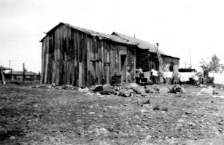

Gov. Castro’s birthplace in Sonora, Mexico

There was only one high school in the small town of Douglas where Gov. Castro grew up, but that does not mean the discrimination ended when there was no segregation. What else in Douglas were signs of racial inequality?
“I heard my older brothers heading to work early in the morning, long before I left for high school, and dragging themselves home at three-thirty or four in the afternoon. They were sweaty, dirty, and very tired. Worse, the smelter had segregated showers with signs that read “Americans Only” and “Mexicans Only.” The Mexican showers were inadequate, if they functioned at all, and, as a practical matter, Mexican workers were unable to shower after work. So my brothers, filthy and covered with dust, escaped into an alcohol haze on a nightly basis. At night three or four of us shared the same bed, and the stench from the liquor disrupted my sleep and taught me some valuable lessons. 3 I thought, Do I want to be like my brothers? Will I be working the rest of my life in the smelter or the mines like them? Is this all there is? It bothered me… I noted that Mexicans comprised the vast majority of the physical labor workforce in Douglas, and indeed in all of the communities on the American side of the border. Few held professional positions.” – Raul Castro

Now listen to Raul’s daughter Beth Castro discuss her father’s experience with discrimination in this oral interview:
https://www.archivetucson.com/people/2019/6/7/castro-beth listen from minute 3:00 to 5:00
What were the motivations that helped Castro decide to fight against the oppressive conditions of his childhood?
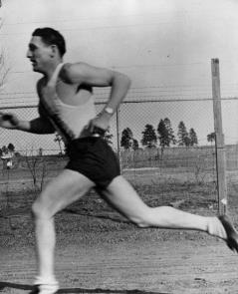

Castro the young athlete.

Background of Segregation of Latinx Americans:
Whether institutionalized in law, informally sanctioned by government officials, or enacted though local custom, whites used segregation to maintain group boundaries and to denote the lower social, political and moral status of non-white groups.
While district officials often claimed that segregation was necessary to effectively address Mexican American students' poor English skills, two factors suggest that this rationale was a “majoritarian story” used to perpetuate white privilege. First, as teacher Wayne Frederick pointed out, Mexican Americans tended to be placed in segregated schools and classrooms for most of elementary school, not just their first years of school. Second, the segregation of Mexican American students in Arizona's public schools occurred in tandem with other discriminatory practices that restricted the social rights of Mexican Americans, many of whom were American citizens with longer roots in their communities than their Anglo neighbors. These included segregation in other public facilities, such as swimming pools, churches, and movie houses, and institutional discrimination in housing policy. All implied that Mexican Americans were racially inferior to whites.
For legal purposes, Mexican Americans were white. They were counted as white in the census, and, unlike non-whites (other than those from Africa), were able to naturalize. However, law clashed with perceptions of racial “reality,” creating a citizenship status for Mexican Americans that many considered to be legal fiction. (Forgotten History: Mexican American School Segregation in Arizona from 1900–1951 by Jeanne M. Powers)
Student Worksheet- Sylvia Mendez
Now it is your turn to learn more about a different aspect of the history of segregation. Below is a primary source relating to your topic and questions to consider about it. Use the internet to search for additional secondary sources that will teach more about your topic.
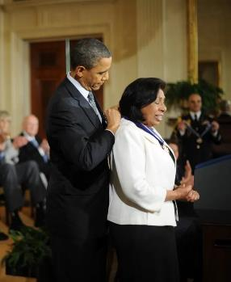

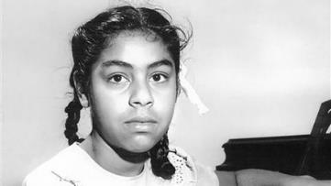

Above is Sylvia Mendez, below is an excerpt from the ruling of her federal case in California. Before you read the court case, answer on a separate sheet of paper some preliminary questions on your own:
- What was Sylvia’s background and what was her court case about?
- When did this court case happen in relation to the landmark case Brown v. Board of Education?
- How did Sylvia continue fighting against discrimination for the rest of her life?

“We perceive in the laws relating to the public educational system in the State of California a clear purpose to avoid and forbid distinctions among pupils based upon race or ancestry except in specific situations not pertinent to this action. Distinctions of that kind have recently been declared by the highest judicial authority of the United States ‘by their very nature odious to a free people whose institutions are founded upon the doctrine of equality.’ They are said to be ‘utterly inconsistent with American traditions and ideals.’ Kiyoshi Hirabayashi v. United States.
Our conclusions in this action, however, do not rest solely upon what we conceive to be the utter irreconcilability of the segregation practices in the defendant school districts with the public educational system authorized and sanctioned by the laws of the State of California. We think such practices clearly and unmistakably disregard rights secured by the supreme law of the land. Cumming v. Board of Education of Richmond County, supra.
‘The equal protection of the laws’ pertaining to the public school system in California is not provided by furnishing in separate schools the same technical facilities, text books and courses of instruction to children of Mexican ancestry that are available to the other public school children regardless of their ancestry. A paramount requisite in the American system of public education is social equality. It must be open to all children by unified school association regardless of lineage.”

After reading the court’s decision, what was their reason for ruling the way they did?

After segregation was legally ended, what other hardships do you think minorities like Latinx faced growing up? Find at least one example online to support your claim.

Now that you have learned more about Sylvia Mendez, prepare to briefly share with the class what you have learned about her contribution to the fight against segregation.
Student Worksheet- League of Latin American Citizens
Now it is your turn to learn more about a different aspect of the history of segregation. Below is a primary source relating to your topic and questions to consider about it. Use the internet to search for additional secondary sources that will teach more about your topic.
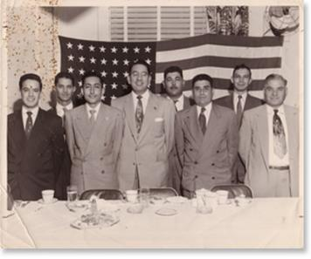

The League of Latin American Citizens was an important organization that was founded to fight discrimination and segregation against Latinx persons in the United States. Before you read the founding code below, research some of the preliminary questions below:
- What were some of the specific goals of the LLAC when it was formed?
- Who were some prominent members and what was their background?
- How did this group contribute to the fight against segregation?

Now read and analyze the LLAC code on the next page.
How does this code apply to the mission of the LLAC?
What work does LLAC do today?
Now that you have learned more about LLAC, prepare to briefly share with the class what you have learned about its contribution to the fight against segregation.
Student Worksheet- Repatriations of the 30s and 40s
Now it is your turn to learn more about a different aspect of the history of segregation. Below is a primary source relating to your topic and questions to consider about it. Use the internet to search for additional secondary sources that will teach more about your topic.
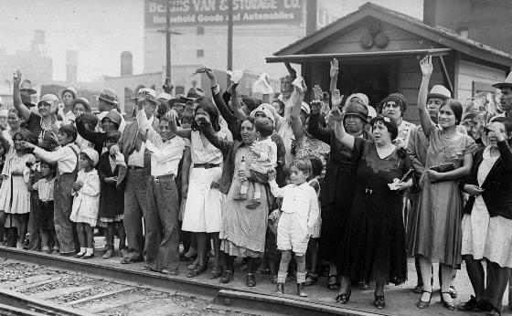

Millions of Mexicans were “repatriated” or expelled from the country in the 20s and 30s. The picture above shows families waving goodbye to as many as 1,000 people being expelled from Los Angeles. Look closely at the picture and make any observations you think are notable. Afterwards answer some questions to understand repatriations better:
- What do you observe about the picture?
- What were the root causes of the anti-Mexican sentiment in the US at that time?
- How does the climate around repatriations in that time compare to attitudes towards immigration today?

Now view the two primary sources on the next page and respond to the questions.

“Figure four hundred thousand deportable aliens. We can pick them all up through police and sheriff channels … You advise please as to method of getting rid.” – Telegram from US official in Los Angeles.

“I am going to tell you gentlemen / Everything I had to suffer / Since I left my nation / Since I left my nation / To come to this country / It may have been ten at night / A train begins to whistle / I heard my mother say / There comes that terrible train / That is taking my son / Goodbye, my dear mother / Give me your blessing / I am leaving to a foreign land / I am leaving to a foreign land / Where there is no revolution.” -Mexican Corrido about repatriation

What stands out to you in the language in the two primary sources? Pick several words and explain their importance.

How are repatriation and segregation related?

Now that you have learned more about repatriations in the 20s and 30s, prepare to share briefly with the class what you have learned and how it relates to the topic of segregation and discrimination.

Student Worksheet- Gonzales v. Sheely
Now it is your turn to learn more about a different aspect of the history of segregation. Below is a primary source relating to your topic and questions to consider about it. Use the internet to search for additional secondary sources that will teach more about your topic.
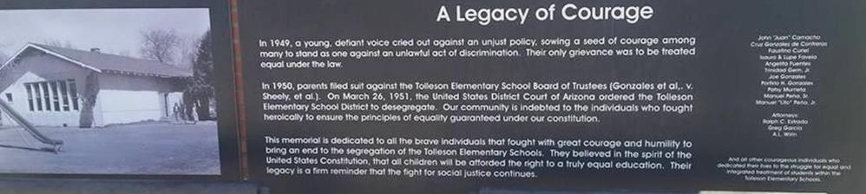

Read the memorial text next to the elementary school where this court case originated and then use the internet to answer these questions and learn more about your topic:
- When did this court case happen in relation to the landmark case Brown v. Board of Education?
- What was the background of the case and what was the outcome?
- How does segregation of Latinx persons compare to that of the blacks going on around the country at the same time?
Now read the excerpts from the court case and answer a few more questions.
IV.
“The respondents' conduct of segregating public school children of Mexican descent or extraction is discriminatory and is illegal and is in violation of petitioners' rights and privileges as guaranteed by the Constitution of the United States. Such official conduct as Public School authorities in the State of Arizona operates to injure and oppress petitioners herein in the free exercise and enjoyment of their rights and privileges as secured and guaranteed to them as citizens of the United States by the Constitution of the United States, and particularly as provided under the Fourteenth Amendment. That petitioners are entitled to equal accommodations, advantages and privileges in the Public Schools in the State of Arizona and to equal rights and treatment with other persons as citizens of the United States in the use and enjoyment of the facilities of said Public Schools, and to equal protection of the laws in their use and enjoyment of said Public School rights and privileges as provided and afforded to other persons at all times when the same are open and used by them.
V.
That said regulations, customs and usages whereby Public School pupils in the respondent School District are segregated are unconstitutional, illegal and void, and are being enforced against petitioners and each of them by discriminatory conduct and practices by respondents and by each of them, through their unlawful acts and conduct; and by their execution of such plan, design and purpose in barring petitioners from the uses and privileges of said Public Schools solely for the cause and reasons as stated in the Findings of Fact, respondents violate petitioners' rights and privileges as citizens of the United States. Such acts are discriminatory, illegal and void.”

After reading the court’s decision, what was their reason for ruling the way they did?

After segregation was legally ended, what other hardships do you think minorities like Latinx faced growing up? Find at least one example online to support your claim.

Now that you have learned more about Gonzalez v. Seely, prepare to briefly share with the class what you have learned about its contribution to the fight against segregation.

