The Rainforest of Costa Rica

ESSENTIAL QUESTION
How is each layer of vegetation in the rainforest different? How do plants and animals interact within a rainforest environment?
ABSTRACT
Students will learn about the different layers of vegetation in the rainforest and the animals that are unique to each layer. Students will study art from Costa Rica and learn about the animals depicted in the artwork. Finally, students will research different features of the Costa Rica rainforest and create a travel brochure about the information.
GRADE LEVELS
5th Grade
SUBJECT AREAS
Science, Visual Arts
CONCEPTS
Environment, Interdependence, Survival, Variation
NC STANDARDS CORRELATIONS
SCIENCE

5.L.2
VISUAL ARTS

5.V.3.3, 5.CX.1.4
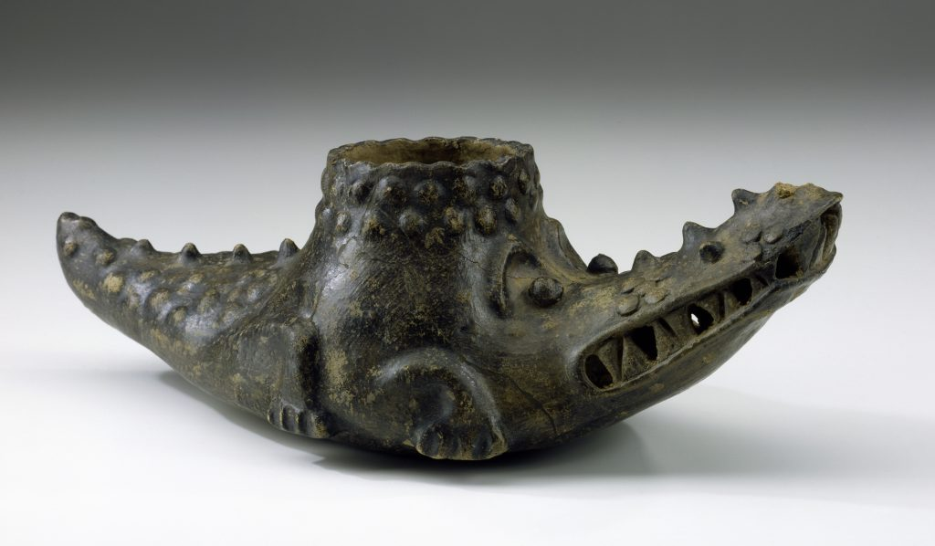
Crocodile Effigy Vessel, by Unknown Costa Rican Artist
Like eagles and jaguars in different habitats, crocodiles are at the top of the food chain

STUDENT LEARNING OBJECTIVES
- Students will investigate the topography and climate of Costa Rica.
- Students will discuss a work of art from Costa Rica and research the animal depicted in the artwork.
- Students will identify the different layers of vegetation and animal life in the rain forest.
- Students will research different aspects of the rainforest in Costa Rica and create a brochure about the information.

Activities

1. Allow students to locate Costa Rica on a world map. Ask students to speculate about the topography and climate of this country. Ask them to predict the types of animals that might live in this environment. Determine the latitude and longitude of the country and discuss its relationship to the equator. Allow students to use Google Earth to explore different regions of Costa Rica and make predictions.
2. Break the class into 11 groups. Using the information from the Moon travel guide to Costa Rica , have each group research a topic The Land and Climate section of the Web site (The Land, A Backbone of Mountains, Meseta Central, Northern Lowlands and Caribbean Coast, Pacific Coast, Geology, Earthquakes, Volcanoes, Climate, Temperatures, Rainfall). Tell students to read their section and create a creative poster about their topic, including facts and pictures. Have the groups share their posters.
3. Have students complete the Costa Rica Reflection Handout based on what they learned from Google Earth and the group presentations.
4. Keeping students in groups, allow the students to study one of the Costa Rican works of art. Ask students to discuss the work of art. Questions include: What do you see in your artwork? What do you think it is made of? What type of animal is depicted by your object? (Collared peccary, crocodile, and jaguar). Ask students to read the art background information for more facts. Allow students to use the Internet or other book resources to research the animal depicted by their piece of art.
5. Project the artwork and have students present their research, telling about the artwork and the animal depicted in the art.
6. Once every group has presented, discuss the animals of the rainforest. Ask: Would all of these animals live in the same part of the Costa Rican rainforest? Why or why not?
7. As a class, discuss the different layers of vegetation found in the rainforest, including the forest floor, understory, canopy, and emergent layer. Have students create a flip foldable, drawing a picture of each layer on the outside of the foldable and listing the physical characteristics of each layer under the picture. Refer to Directions to Flip Foldable Handout.
8. Show students the Rainforest Virtual Field Trip PowerPoint and ask students to take notes on each layer of the rainforest on their foldable. Students can also use the textbook or Internet resources to find information for the foldable. Students should then draw each layer on a separate flap of the foldable so that each layer of the rainforest has its own separate flap, but together, the flaps make an entire picture of the vegetation layers of the rainforest.
9. Give students a large piece of drawing paper with crayons, markers, colored pencils, or collage materials and glue. Have them fold their papers into the four sections and label the layers of vegetation. Have students draw a background of the rainforest. Using the Rainforest Animals Handout, students should cut out the animals, color them, and glue them into the correct locations of the rainforest.
10. Have students create a travel brochure that promotes Costa Rica’s rainforest. The brochure should tell about the weather and environment, ecology, travel information, and endangered species. Refer to the Rainforest Travel Brochure and Rubric Handout. The brochures can be displayed alongside the students’ collages of the rainforest and the rainforest foldable.
Written by Jennifer Rogers, Science Teacher

Assessments
1. Group discussion, poster, and presentation will demonstrate students’ knowledge of aspects of Costa Rica.
2. Costa Rica Reflection Handout will demonstrate students’ understanding of the characteristics of Costa Rica.
3. The rain forest drawing will assess the students’ knowledge of the various layers of the rain forest and the animal and plant life at each level.
4. The Costa Rica travel brochure will assess students’ understanding of life in the Costa Rica rainforest. (rubric)
Lesson Resources
Vocabulary
forest floor
understory
canopy
emergent layer
peccary
humming bird
resplendent
quetzal

Materials
Computers with Google Earth capabilities and Internet
Access to projector
Links
Costa Rica Web site

Peccary Effigy Jarby by Unknown Costa Rican Artist

