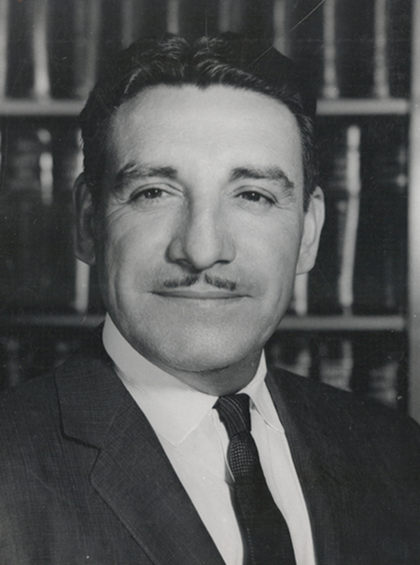
Life and Legacy of Raul H. Castro High School Lesson Series
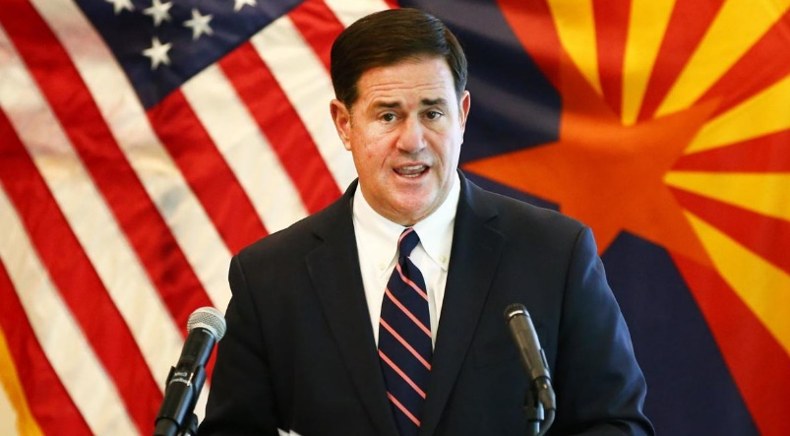
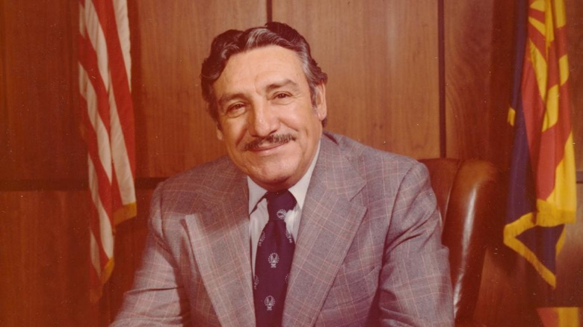

Civics Lesson: Governor Castro and the Governorship Today

Civics Lesson Teacher Guide
The following lesson contains two documents:
- One comprehensive summary of gubernatorial responsibilities
- Excerpts from Raul Castro’s time as governor.
The goal of this lesson is to learn more about the responsibilities of the governor in modern day and compare and contrast the experience of Governor Raul Castro. This lesson is reading intensive and can be assigned and divided as needed.

Resources and Background Information
The following resources can be used to learn more about Governor Raul Castro to teach the class more about Arizona’s first and only Mexican governor.
- http://digitalcommons.library.arizona.edu/x/exhibits/rhcastro/lifestory UA Special Collections
- The autobiography Adversity Is My Angel: The Life and Career of Raul H. Castro, check local library for availability
- https://www.nga.org/governors/powers-and-authority/
- https://www.icivics.org/teachers/lesson-plans/state-governor

Arizona History and Social Science Standards:
Disciplinary Skills and Processes
- HS.SP1.1 Evaluate how events and developments were shaped by unique circumstances of time and place as well as broader contexts.
- HS.SP1.3 Evaluate the significance of past events as they relate to their own lives and the world.
- HS.SP1.4 Use compelling questions generated about individuals and groups to assess how the significance of their actions changes over time and is shaped by the historical context.
- HS.SP3.2 Gather relevant information from multiple sources representing a wide range of views while using origin, authority, structure, context, and corroborative value of the source to guide the selection.
- HS.SP3.1 Develop and frame questions about issues and events in the discipline and determine the types of sources that will be helpful in answering these questions.
- HS.SP3.3 Analyze the relationship between primary sources and the secondary interpretations made from them including possible limitations in various kinds of evidence and differing secondary interpretations.
- HS.SP3.4 Evaluate the credibility of a source by examining how experts value the source.
• HS.H2.2 Analyze approaches to conflict management and resolution.
• HS.H2.3 Evaluate the short- and long- term impacts of conflicts and their resolutions.

Overview of Governor’s Responsibilities
Governors, all of whom are popularly elected, serve as the chief executive officers of the fifty states and five commonwealths and territories.
As state managers, governors are responsible for implementing state laws and overseeing the operation of the state executive branch. As state leaders, governors advance and pursue new and revised policies and programs using a variety of tools, among them executive orders, executive budgets, and legislative proposals and vetoes.
Governors carry out their management and leadership responsibilities and objectives with the support and assistance of department and agency heads, many of whom they are empowered to appoint. A majority of governors have the authority to appoint state court judges as well, in most cases from a list of names submitted by a nominations committee.
Although governors have many roles and responsibilities in common, the scope of gubernatorial power varies from state to state in accordance with state constitutions, legislation, and tradition, and governors often are ranked by political historians and other observers of state politics according to the number and extent of their powers. Ranking factors may include the following.
- Qualifications and tenure
- Legislative—including budget and veto—authority
- Appointment sovereignty
Although not necessarily a ranking factor, the power to issue executive orders and take emergency actions is a significant gubernatorial responsibility that varies from state to state.
Qualifications And Tenure
Qualifications
States, commonwealths, and territories vary with respect to minimum age, U.S. citizenship, and state residency requirements for gubernatorial candidates and office holders. The minimum age requirement for governors ranges from no formal provision to age 35. The requirement of U.S. citizenship for gubernatorial candidates ranges from no formal provision to 20 years. State residency requirements range from no formal provision to 7 years.
Term Limits
Gubernatorial terms are four years in every state, commonwealth, and territory but New Hampshire and Vermont, which have two year terms. All governors with the exception of Virginia’s may succeed themselves, although they may be limited to a specific number of consecutive or total terms.
For state by state information on gubernatorial qualifications, see “The Governors: Qualifications for Office“(Table 4.2, The Book of the States 2019, source: The Council of State Governments).

Vacancies/Succession
In the event of a vacancy in office, the lieutenant governor is the designated official who succeeds the governor in 49 states and territories (in two of which—Tennessee and West Virginia—the president/speaker of the Senate and lieutenant governor are one and the same). In the remaining 5 states and the Commonwealth of Puerto Rico, officials designated to succeed the governor include the secretary of state and leader of the senate.
Impeachment
All states except Oregon provide for the impeachment of governors. As in the case of the federal government, the impeachment process starts with the lower body of the legislature and the trial is conducted by the upper body in every state but Alaska—where the process is reversed, and Nebraska, which has a unicameral legislature charged with the full impeachment process. In most cases, impeachment requires a majority of members, while conviction generally requires a two-thirds or other special majority.
Legislative Role
Governors play two broad roles in relation to state legislatures. First, they may be empowered to call special legislative sessions, provided in most cases that the purpose and agenda for the sessions are set in advance. Second, and more familiarly, governors coordinate and work with state legislatures in:
- approval of state budgets and appropriations;
- enactment of state legislation;
- confirmation of executive and judicial appointments; and
- legislative oversight of executive branch functions.
Approval Of State Budgets And Appropriations
Governors develop and submit annual or biennial budgets for review and approval by the legislature. In a number of states, commonwealths, and territories, governors also have “reduction”—most often referred to as “line-item”—veto power that can be used for the removal of appropriations to which they object. These tools allow governors and their budget staff to play a strong role in establishing priorities for the use of state resources. For state by state information on gubernatorial budget making and line-item veto power.
Enactment Of Legislation
Governors often use State of the State messages to outline their legislative platforms, and many governors prepare specific legislative proposals to be introduced on their behalf. In addition, state departments and agencies may pursue legislative initiatives with gubernatorial approval. Executive branch officials often are called to testify on legislative proposals, and governors and other executive branch leaders will seek to mobilize public opinion and interest groups in favor of or opposition to specific legislative proposals. Governors may use their role as party leaders to encourage support for legislative initiatives, and along with department heads and staff may seek to influence the progress of legislation through regular meetings with legislators and legislative officials.
Veto Power
All 50 state governors have the power to veto whole legislative measures. In a large majority of states a bill will become law unless it is vetoed by the governor within a specified number of days, which vary among states. In a smaller number of states, bills will die (pocket veto) unless they are formally signed by the governor, also within a specified number of days. Other types of vetoes available to the governors of some states include “line-item” (by which a governor can strike a general item from a piece of legislation), “reduction” (by which a governor can delete a budget item), and “amendatory” (by which a governor can revise legislation). Legislatures may override vetoes, usually by a supermajority vote.
Legislative Oversight
Governors interact with their legislatures to help ensure that their priorities, goals, and accomplishments are accurately presented and positively received during oversight hearings and other legislative activities that address and evaluate executive branch implementation of legislatively mandated programs and services.
Appointment Power
Gubernatorial Appointments – Overview
Most governors have broad authority to nominate officials to serve in state executive branch positions—many of whom will be included in the governor’s advisory committee, known as the “cabinet.” Governors may be empowered as well to make appointments to state judgeships. Frequently, these appointments are subject to confirmation by one or both houses of the state legislature. While often pro forma in nature, the confirmation process with respect to executive branch appointments can be used by legislatures to expand their influence on governors and their policies. Accordingly, many governors consult with key legislators before making formal nominations.
Boards And Commissions
The roles played by boards and commissions vary considerably by state and by program. In some states appointed boards have the primary responsibility for individual programs and agencies and are responsible for the selection of department and agency heads. This is particularly true in the field of education, but boards still retain responsibility for a broad range of other programs in fields such as labor, transportation and health and human services.
In many states the members of these boards are named or nominated by the governor. And in many of these cases, board members are subject to confirmation by one or both houses of the legislature.
Other boards play more limited regulatory or advisory roles. In most states boards oversee the licensing and regulation of numerous professions and business areas. In other states they advise the governor on areas of importance such as the environment and economic development.
While the elimination and/or consolidation of boards and commissions is a common focus of government efficiency and government reorganization initiatives, they still play a prominent role in state government, providing opportunities to address the concerns of special interests and to reward political supporters.
Executive Branch Positions Independently Selected
A large number of states provide for the independent selection of certain executive branch positions. Most noteworthy among these positions are lieutenant governor, secretary of state, attorney general, and treasurer.
The position of lieutenant governor exists in the overwhelming majority of states, where the position is most often filled by popular statewide election and jointly with the governor, although in a small number of cases the role of lieutenant governor is assigned by state law to another position in either the executive or legislative branch (e.g., secretary of state or leader of the senate). The positions of secretary of state, attorney general, and treasurer are all subject to statewide popular election in the majority of states, and at least one of the three is elected in most of the remaining states.
Governors generally have limited authority in the appointment of state comptrollers and pre and post audit department heads. Governors’ appointment powers are also limited with regard to the heads of state education and higher education agencies. The education department head is independently elected statewide in 14 states and is appointed—independent of gubernatorial approval—by a board or agency head in 20 states and two territories. In most states and territories, the higher education head is appointed by a board independent of gubernatorial approval.
A number of states also provide for the statewide election of one or more other department heads, among them public utility regulators and the heads of agriculture, labor, and natural resources departments.
As with governors, other statewide elected positions may be subject to age, citizenship, and state residency requirements, as well as term limits.
Cabinets
State cabinets, which serve as advisory councils to the nation’s governors, generally are made up of officials appointed by the governor to head state departments and agencies, and in some cases top-level staff in the governor’s immediate office. In most states the cabinet fulfills two functions:
- advises the governor on the development of policy; and
- serves as a vehicle for the governor or senior staff to convey priorities to gubernatorial appointees and address cross-agency issues or concerns.
In a number of states, governors have created sub-cabinets to bring together agencies to address issues such as the needs of children.
Forty-four states and all of the commonwealths and territories have cabinets and/or sub-cabinets. Cabinets themselves may have their origin in law, tradition, and/or the governor’s discretion. Cabinet membership may be a product of appointment to a specific office or be subject to selection by the governor. Cabinet size, and the frequency of cabinet meetings and formality and extent to which a governor uses his or her cabinet for advice and assistance, varies among the states, commonwealths, and territories.
Executive Orders
The authority for governors to issue executive orders is found in state constitutions and statutes as well as case law, or is implied by the powers assigned to state chief executives. Governors use executive orders—certain of which are subject to legislative review in some states—for a variety of purposes, among them to:
- trigger emergency powers during natural disasters, energy crises, and other situations requiring immediate attention;
- create advisory, coordinating, study, or investigative committees or commissions; and
- address management and administrative issues such as regulatory reform, environmental impact, hiring freezes, discrimination, and intergovernmental coordination.
Emergency Powers
As chief executive, governors are responsible for ensuring their state is adequately prepared for emergencies and disasters of all types and sizes. Most emergencies and disasters are handled at the local level, and few require a presidential disaster declaration or attract worldwide media attention. Yet governors must be as prepared for day-to-day events—tornadoes, floods, power outages, industrial fires, and hazardous materials spills—as for catastrophes on the scale of Hurricane Katrina or the September 11 terrorist attacks. States focus on four stages of disaster or emergency management:
- Prepare
- Prevent
- Respond
- Recover
These components afford a useful rubric for thinking about the cycle of disasters and emergencies and for organizing recommendations for state action. During an emergency, the governor also plays a key role in communicating with the public during an emergency, providing advice and instructions and maintaining calm and public order.
State emergency management laws usually define how a governor may declare and end a state of emergency. In some cases, the necessary response to a disaster is beyond the capacity of state and local governments. A state may petition the President to declare a major disaster. The declaration of a major disaster triggers a variety of federal programs depending on the scope of the disaster and the type of losses experienced.

Excerpts from Gov Castro
“My tenure as governor exposed me to the strengths and limitations of Arizona’s constitution, a document crafted in the era of Progressive reform at the beginning of the twentieth century. In short, Arizona’s governor, by constitutional design, has limited executive powers. The legislature, I learned quickly, maintained equal or greater power, and programs I championed were often bottled up in the House and Senate. I worked more as an administrator than as a leader in formulating and executing public policy and economic reform. I labored at meeting the state payroll, repairing bridges, paving highways, and providing food and healthcare for state prisoners, since they routinely sued me over food and access to healthcare. The daily duties of the governor’s office proved more mundane than my initial impressions. During my time in the governor’s chair I made some, but not all, of the improvements in Arizona I had hoped to accomplish. Unfortunately, the state faced a financial crisis when I took over.
“Working with the private sector and the legislature, I was able to navigate the ship of state out of choppy fiscal waters. When I took office, the nation and Arizona were in the midst of a recession, and I discovered that we had a shortfall of funds to pay state workers. I reduced the executive budget, cutting one million dollars from the previous year despite 10 percent inflation that year, then I called all of the state’s leading bank presidents, told them we had a crisis and they needed to be sure that they had enough money in their respective institutions in order for the state to borrow enough to make payroll. With that assistance we avoided an immediate crisis, and shortly thereafter I had every state agency cut its budget by 10 percent. Such draconian measures did little to endear me to state employees, but it was a necessary and responsible course to take.
“I convinced President Ford to release impounded federal highway construction funds, which helped reinvigorate our moribund construction industry. In addition, I created the Arizona Commission on the Status of Women and the Office of Affirmative Action in Arizona. To promote trade and tourism, I established the Department of Tourism and expanded the Four Corners Regional Commission to include all Arizona counties. I organized the Border States Regional Commission to deal with US-Mexico border problems, including appointing Pima County attorney Dennis DeConcini as the chief law enforcement official to fight the war on drugs. Finally, I set up a national and international trade commission to promote Arizona exports and foreign investments with the Far East, Europe, the Middle East, and Latin America. Clearly my experience outside the US as an ambassador influenced the nature and direction of my years in the governor’s chair.”

Questions for Discussion and Further Research

- What were some of the responsibilities of the state governor that you learned about that Gov. Castro demonstrated in his term?

- What are some of the limitations to the Arizona Constitution that Governor Castro alludes to? How has the constitution changed since he was in office?

- If you were elected Governor of Arizona, what would some of your first priorities be? Using some of what you learned today, write down some ideas as to how you would go about accomplishing your goals.

- Research more about Arizona’s current governor. What are his priorities and initiatives? How has he demonstrated his gubernatorial power recently?

